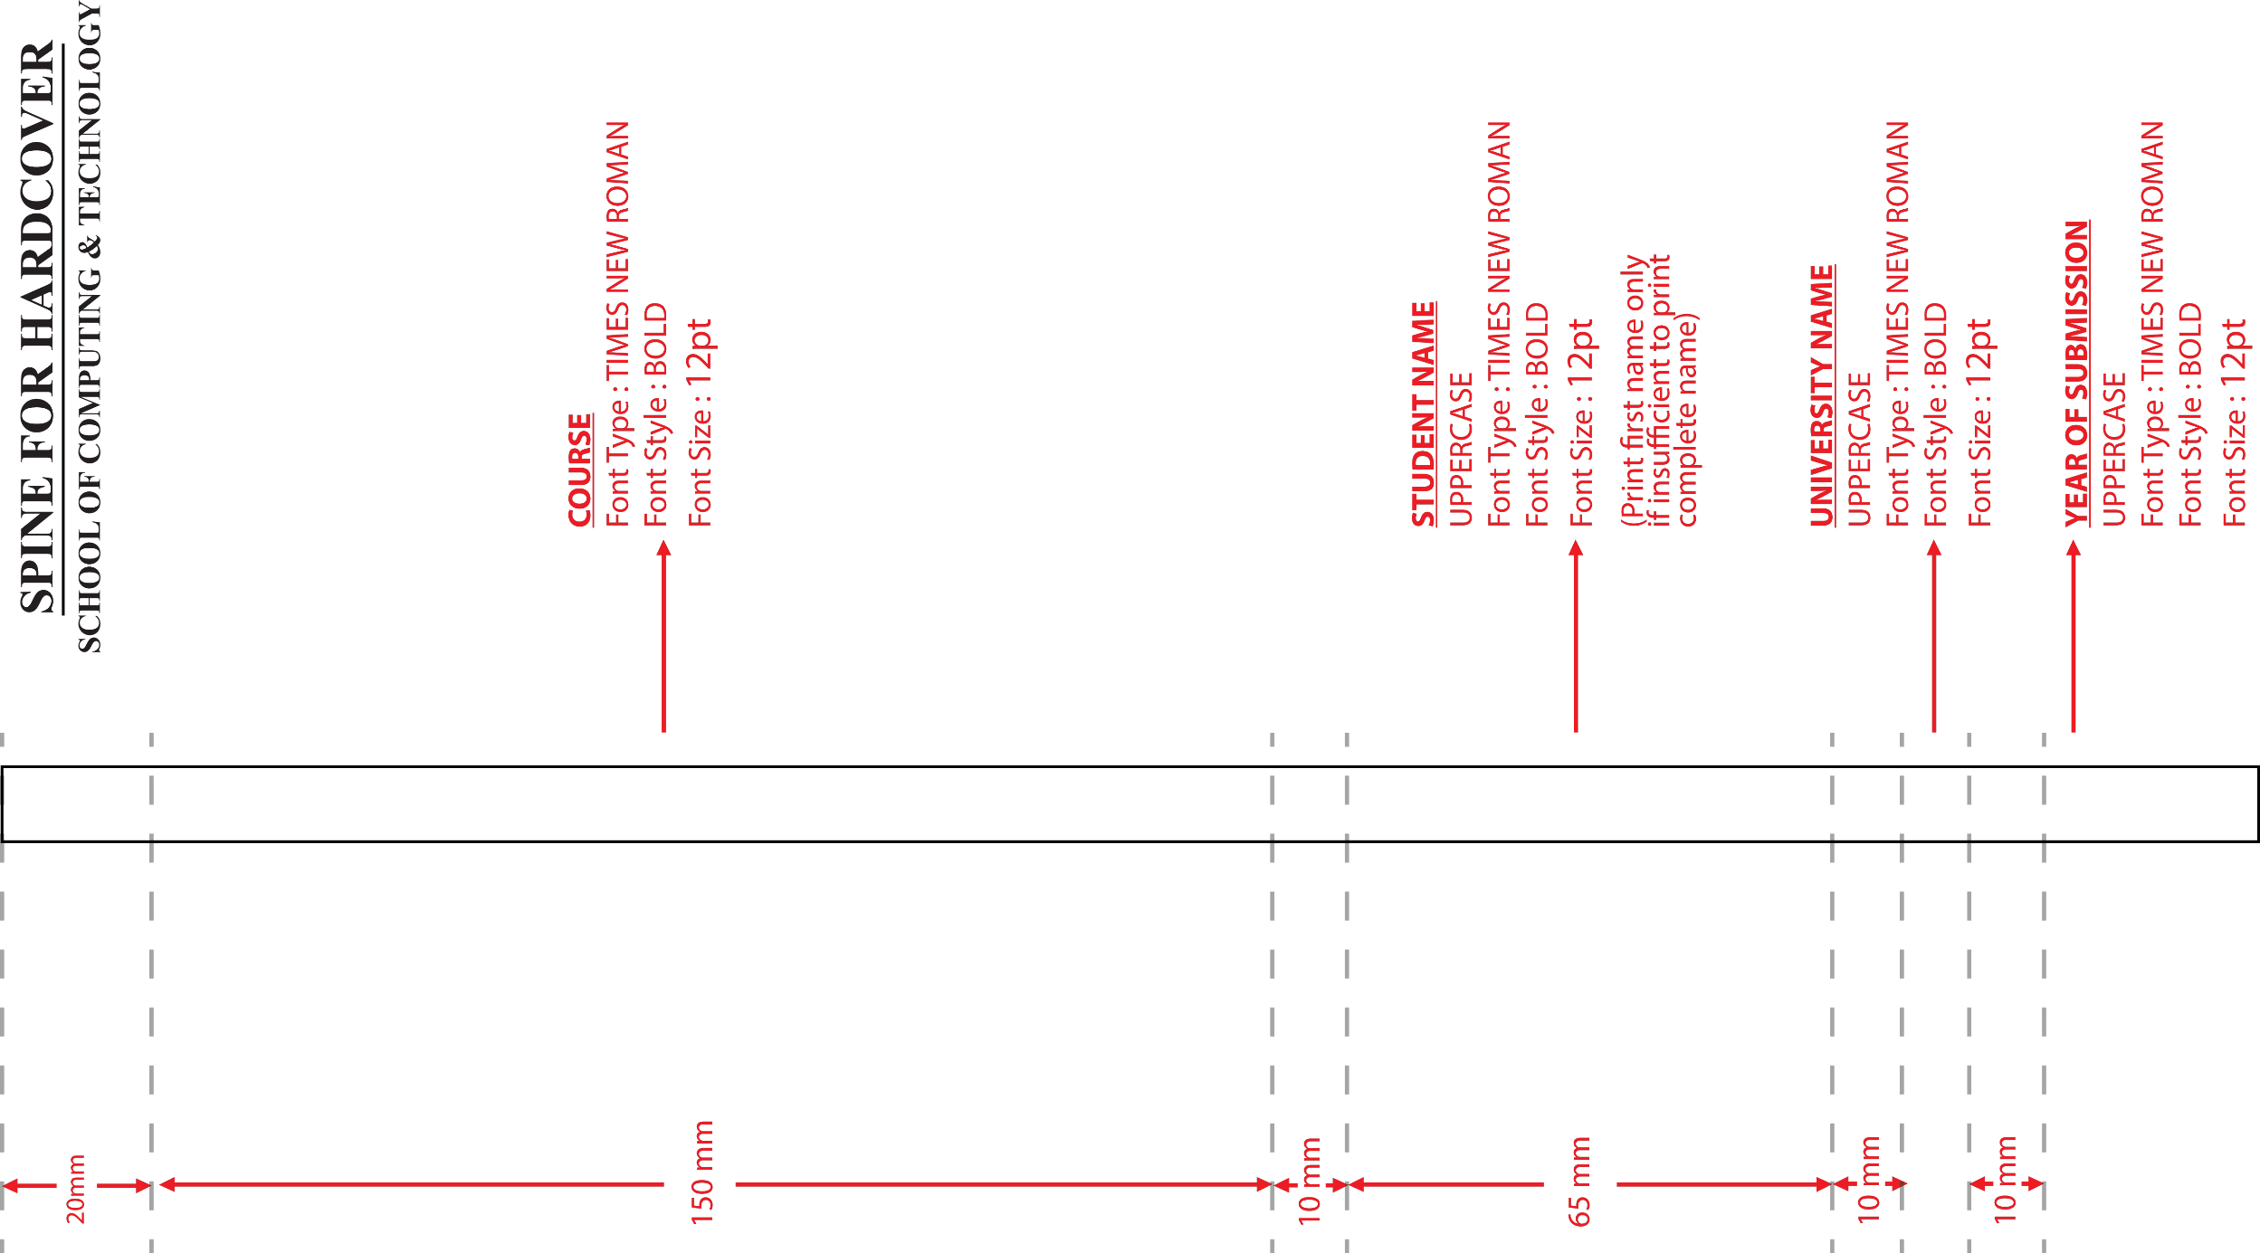**Enter Your Programme example BSc (Hons) in Information Technology**

**NAME APU 2018**

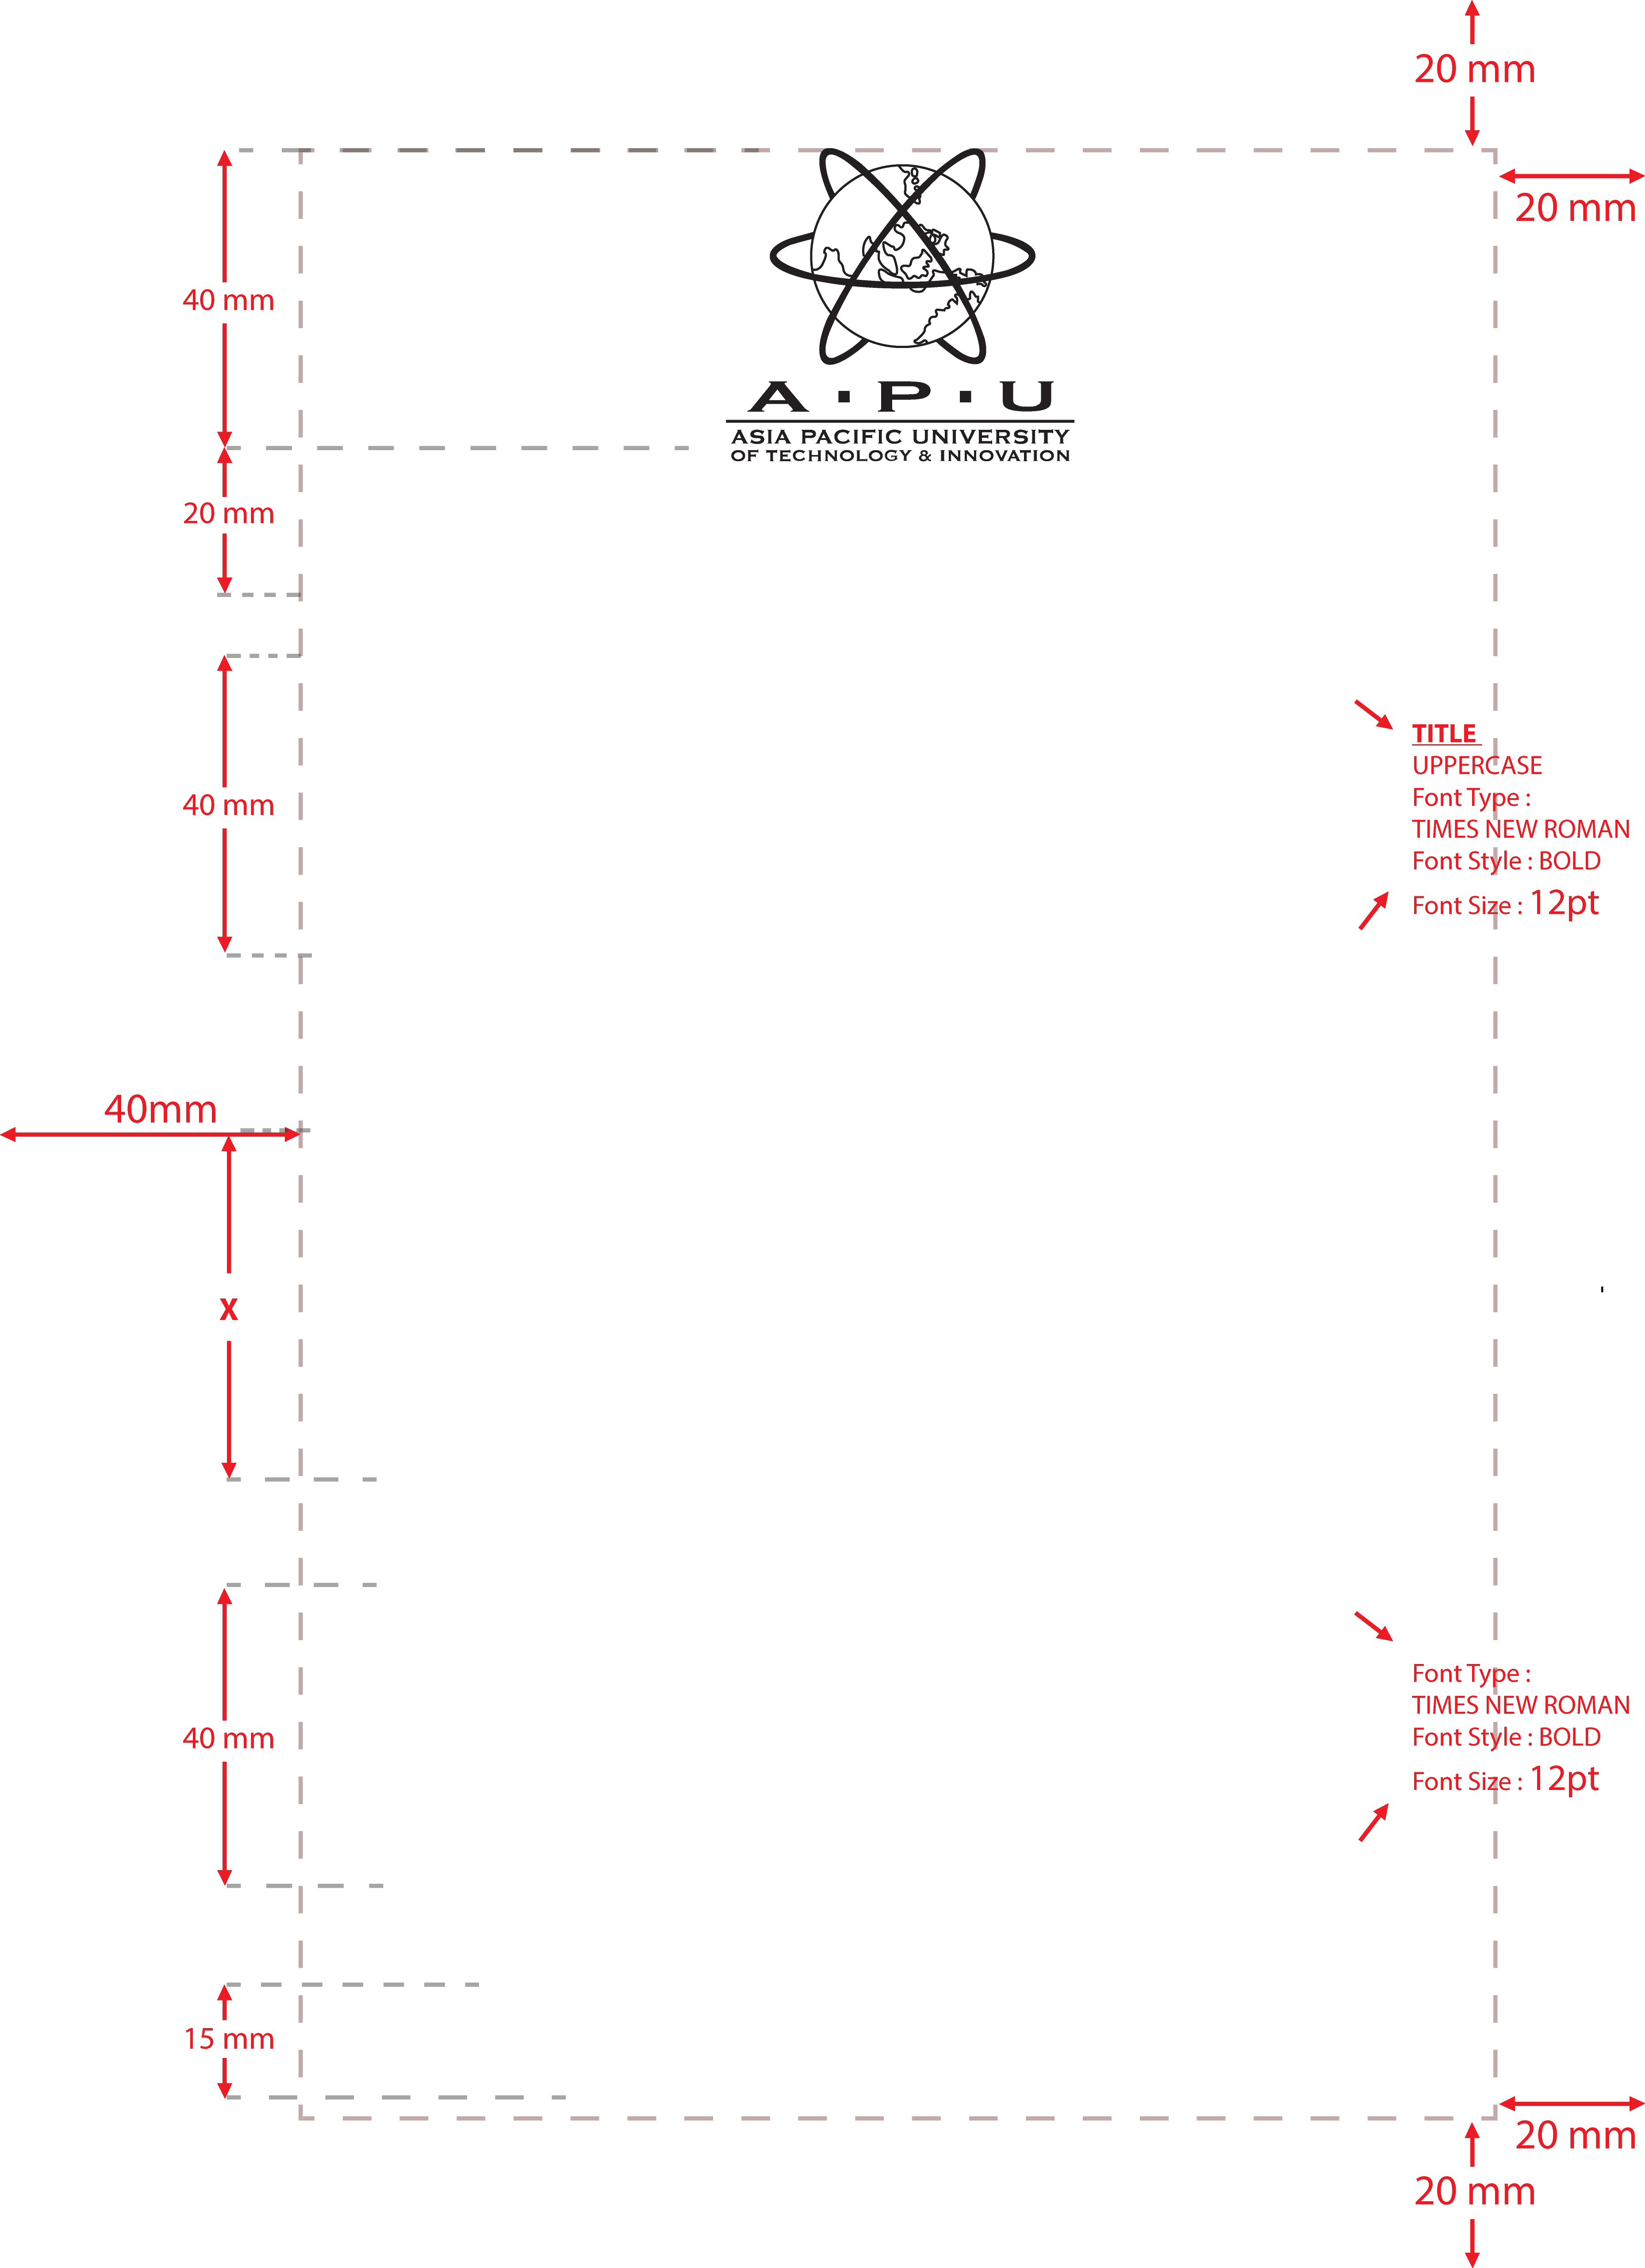

**ENTER YOUR PROJECT TITLE XXXXXXXXXXXXXXXXXXXXXXXXXXXXXXXXXXXX**

**STUDENT NAME**

**STUDENT NUMBER**

**INTAKE**

**PROGRAMME**

**SUPERVISOR NAME**

**A project submitted in partial fulfillment of the requirement**

**For the degree of**

**Enter Your Programme example BSc (Hons) in Information Technology**

**ASIA PACIFIC UNIVERSITY OF TECHNOLOGY AND INNOVATION FACULTY OF COMPUTING, ENGINEERING & TECHNOLOGY**

**SCHOOL OF COMPUTING & TECHNOLOGY**

**MONTH YEAR**